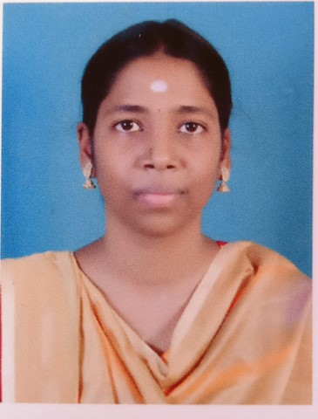

**PROFILE**

Bsc computer science

student.

I consider my self a

responsible and orderly

person.

I am looking forward for

my first work

experience.

**CONTACT ME**

+91 84380 30216

thanukamu16@gmail.com

st,muthusamy

21

nagar, sivagangai.

**VOLUNTEER EXPERIENCE**

.State level seminar attending..."Recent

1

challenges in cloud computing security"

(

idhaya college for womens

).

2

.National seminar attending ..."Advanced

computing technologies"(Madurai sivakasi

nadar's pioneer meenakshi womens college ).

3

.Internship as a volunteer in maditssia

indexpo held ,at IDA scudder convention

center Madurai.

4

.Life skill seminar attend Tamilnadu

chamber of commerce Madurai July 2023

**EDUCATION**

*Madurai sivakasi nadar's pioneer*

*meenakshi womens college.(2021-2024)*

*HSC(Matriculation)-77%(2021)*

*SSLC(Matriculation)-67%(2019)*

**LANGUAGE**

Native Tamil

English

**COMPUTER SKILLS**

Ms office

THANUSHREE .K.P

*Student*

Excel

Powerpoint

**ABOUT ME**

**DOB:16/02/2004**

**FATHER NAME: J.Kanmanirajam**

**NATIONALITY: Indian**

**MARITAL STATUS:Single**

|  |  |
| --- | --- |
| **Place: Date:** | **Yours truly, Thanushree** |

I hereby declare that all the details furnished above are true to the best of my knowledge